**Setup Oracle virtual box as same as in week 1 and Download window file for vm which is given in moodle.**

**PowerShell script (`defend.ps1`)**

* Step 1.Download script from this git repo : <https://github.com/anilH3inso/Powershell_script.git> and Extract it in shareable folder if you are using VM’s

Fig 1. Download

Here I extract it in my shared folder and go in child path where defend.ps1 is.

Fig 2. Extract

* Step 2. Open the folder and locate base file named defend.ps1 Stay on same path and Create three folder by name ‘**Source**’ (optional), ‘**Backup**’, and ‘**Restore**’ Then **Click Shift + Right mouse button** to open PowerShell.

Fig 3. Create Folder.

Fig 4. Open PowerShell

* Step 3. Before using the script, ensure that Chocolatey is installed on your system. You can install Chocolatey by downloading the script from <https://github.com/anilH3inso/chocolatey.git> .
* Step 4. Run the script to install GPG4Win by typing:

“ .\defend.ps1 installGPG “

* Step 5. Set Up GPG Key

After GPG4Win is installed, you need to set up a GPG key.

Run the script to set up the GPG key by typing:

“ .\defend.ps1 setupGPG “

Follow the prompts to generate a GPG key. You may need to provide details like your name and email address. You also need to set password for encrypt and decrypt.

* Step 6. Backup Files.

Once GPG4Win is installed and the GPG key is set up, you can use the script to backup your files securely.

Prepare the files you want to backup and remember their source folder path.

* Step 7. Run the script to backup the files by typing:

“ .\defend.ps1 backup “

Choose your full path of file which you want to backup in my case it is located in ‘.\Source’ with ‘hello.txt’ name.



Follow the prompts to enter the path to the source folder containing the files you want to backup.

You can check Backup folder weather it is backup or not.

* Step 8. Restore Files.

If you need to restore the backed-up files at any point, you can use the script to decrypt and restore them.

Run the script to restore the files by typing:

“ .\defend.ps1 restore “

-You need to enter password to restore it , password will be the one which you set at setupgpg step.

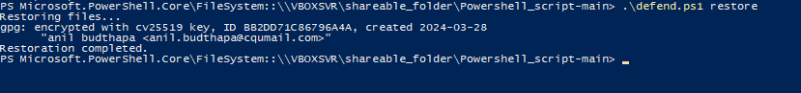

- The script will decrypt the backed-up files and restore them to a specified folder.

-Now you can get your file restore in restore folder.

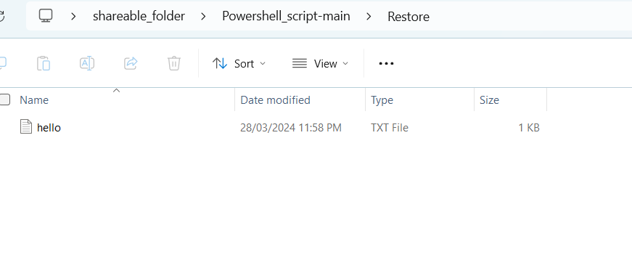



## Additional Notes

- Ensure that you have appropriate permissions to access the files and folders involved in the backup and restoration process.

- Make sure to handle the generated GPG key securely, as it is crucial for encrypting and decrypting your files.